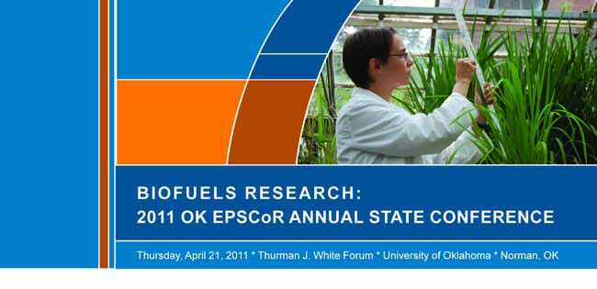
POSTER SESSION ABSTRACT SUBMISSION FORM

DEADLINE FOR SUBMITTING ABSTRACTS: APRIL 5, 2011
- Submit abstracts and this form via email to: gmiller@okepscor.org
Both files must be submitted in MS Word format—NOT PDF
- Maximum poster size: 40” X 36” (larger posters not accepted)
- Abstract word limit: 300 words maximum
- EVERYONE must register for the conference online at www.okepscor.org in addition to submitting abstracts and poster session forms via email.

Please note: It is not necessary to participate in the hybrid poster/oral presentation competition to present a poster during the scientific poster session. Only students may participate in the competition portion of the event, but anyone may participate in the scientific poster session.

- NAME(S) OF PRESENTER(S) WITH AFFILIATIONS FOR EACH:

- LEAD PRESENTER’S EMAIL ADDRESS:

- TITLE OF POSTER:

- THEME AREA: (Indicate one of the following—Feedstock Development, Microbial Conversion or Chemical Conversion, if applicable)

- IF YOU ARE A STUDENT, PLEASE INCLUDE THE FOLLOWING:
ADVISOR’S NAME:
ADVISOR’S EMAIL:

- SAVE THIS FORM AND YOUR ABSTRACT IN MS WORD FORMAT AND EMAIL BOTH TO GMILLER@OKEPSCOR.ORG

- REGISTER FOR THE CONFERENCE ONLINE AT WWW.OKEPSCOR.ORG

- IF YOU WISH TO PARTICIPATE IN THE STUDENT-ONLY HYBRID POSTER/ORAL PRESENTATION COMPETITION, INDICATE YOUR COMMITMENT TO PARTICIPATE BY NOTING YOUR RESEARCH FOCUS ON THE LINE BELOW. *Research focus MUST BE Feedstock Development, Microbial Conversion or Chemical Conversion to participate in the competition.

I wish to participate in the hybrid poster/oral competition, and my research focus is:

*_______________________________________________

SEE BELOW FOR DETAILED HYBRID ORAL/POSTER PRESENTATION COMPETITION RULES & INFORMATION

2011 OK EPSCoR ANNUAL STATE CONFERENCE
*HYBRID ORAL/POSTER PRESENTATION COMPETITION RULES & INFORMATION*

Students who indicate on their submitted abstract forms that they wish to participate in the hybrid poster/oral presentation competition will be sent a mandatory-use PowerPoint template via email after their registration and abstracts are received.

Please review the following hybrid competition rules and guidelines:

- Participants must be undergraduate or graduate students only

- Students must be presenting posters based on research they performed under the current OK EPSCoR RII Award’s funding

- Students must participate in both the oral and poster presentation sessions

- Theme area, based on the three research areas noted above, must be indicated on students’ abstract submission forms, along with an indication that they wish to participate in the competition. Theme area must be one of the following: Feedstock Development, Microbial Conversion or Chemical Conversion

- Maximum of 15 students per theme area

- Online registration and abstract submission deadline for the competition is April 5, 2011(or when full)

- Students will be given a maximum of three minutes each for their oral presentations, which should be designed to provide an overview of the research poster that they will present during the subsequent judged poster session

- PowerPoint presentation submission deadline is April 14, 2011. If slides are not provided by that date, the student may not participate in the competition.

- No changes or updates may be made to slides after they are submitted

- Flash drives will not be allowed. EPSCoR will have students’ slides uploaded to the site computer for the presentations.

- Students must use the provided 5-slide PowerPoint template and not vary from that format (this includes the addition of animation, which is not allowed). Any variance from the provided slide template or the use of more than five slides will disqualify the participant.

- Information provided in the slides must include: title, objectives, methods, results and conclusions, per the provided slides

- Presentations developed on Mac computers are not supported by the site’s projectors, so PCs only may be used.

Brief outline for participating in the hybrid poster/oral presentation competition:
- Access the poster session form online at www.okepscor.org.
- Submit your completed form, along with your abstract, to gmiller@okepscor.org in MS Word format prior to the April 5 deadline.
- Be sure to indicate your research category and your commitment to participate in the competition on your completed poster session form. Fill the form out completely.
- Carefully review the competition rules, which are outlined above on the poster session form.
- After submitting your abstract and poster session form, you will receive (via email) the required oral presentation slide template.
- Register for the conference online via the link at the bottom of this page by April 14. YOU MUST REGISTER FOR THE CONFERENCE ONLINE at www.okepscor.org IN ADDITION TO SUBMITTING YOUR ABSTRACT AND POSTER SESSION FORM VIA EMAIL.
- Submit your presentation slides, per the rules and provided template, to Gina Miller at gmiller@okepscor.org no later than April 14. (Late submissions or presentations outside of the approved template and slide count will not be accepted.)

